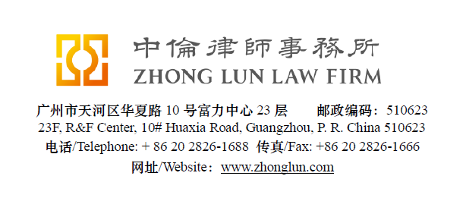

Invoice / 收款通知书

Date  日期 | 28/07/2019 | ZL Invoice Reference  中伦收款通知编号 | 049342-0001/047
Client  客户 |  | 元气寿司餐饮服务管理（深圳）有限公司广州分公司  Attn: Koko LONG  广州市天河区林和中路63号东方宝泰负三层3050及3051
Subject Matter  事项 | General | Service Period  服务期限 | June 2019
Legal Fee  律师费 | RMB 900 | Reimbursement  报销费用
Sum Now Due  总应付款 | RMB 900

Please make the payment to the banks account as follows:
请将上述款项付至下列账户：

Account Number  账号 | 1209 0403 9310 502 | Swift Code  银行代码 | CMBCCNBS131
Account Name  账户名称 | Beijing Zhong Lun Law Firm Guangzhou Office  北京市中伦（广州）律师事务所
Bank Name  开户行 | China Merchants Bank, Guangzhou Branch, R&F Center Subbranch  招商银行广州分行富力中心支行
Address  地址 | 2/28F R&F Center, 10 Huaxia Road, Guangzhou, China  广州市华夏路10号富力中心2/28楼

Zhong Lun Law Firm 中伦律师事务所
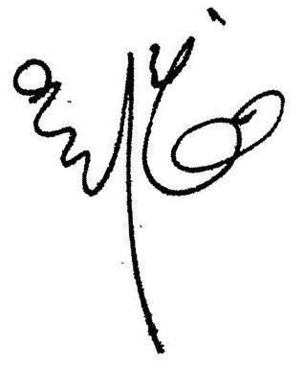

Charge Details / 收费明细

To our Professional Charges for our service rendered in respect of the following:
中伦律师事务所就如下事宜提供了专业服务：

 | Service Provided  已提供之服务 | Cost (RMB)  费用（人民币）
- 1. | Conducting the search on the property at Room 334, Xicheng Duhui Square, No. 8 Huangsha Avenue, Liwan District, Guangzhou City. [广州市荔湾区黄沙大道8号广州西城都荟广场334房（自编号330-332号商铺）]. | 900
 | Total/合计: | 900

Please kindly indicate the ZL Invoice Reference number on your bank processing document and provide us a copy of the bank confirmation for the payment. /请在银行付款单据上标明中伦收款通知编号，并向我方提供相关银行确认书。
Please pay equivalent foreign currency if a RMB account is not available. /若未能支付人民币，请支付等值外币。
Please indicate the FULL name in the bank advice and state the FULL name at the remark or note section on the bank advice./ 请在银行付款单据上列明全称并在汇款附言或备注栏填入收款人全称。

